**Exercise 1: Control Structures**

**Output:**

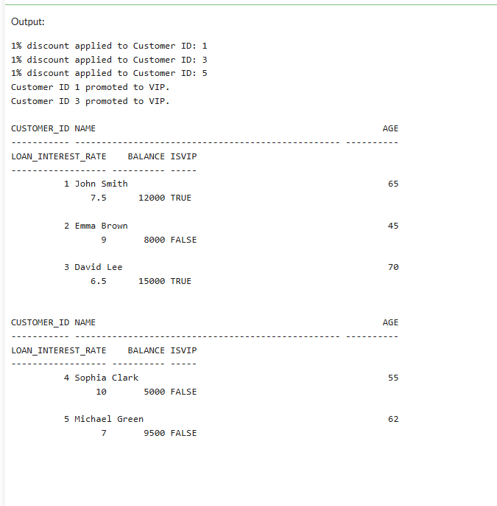

**Exercise 2: Error Handling**

**Output:** 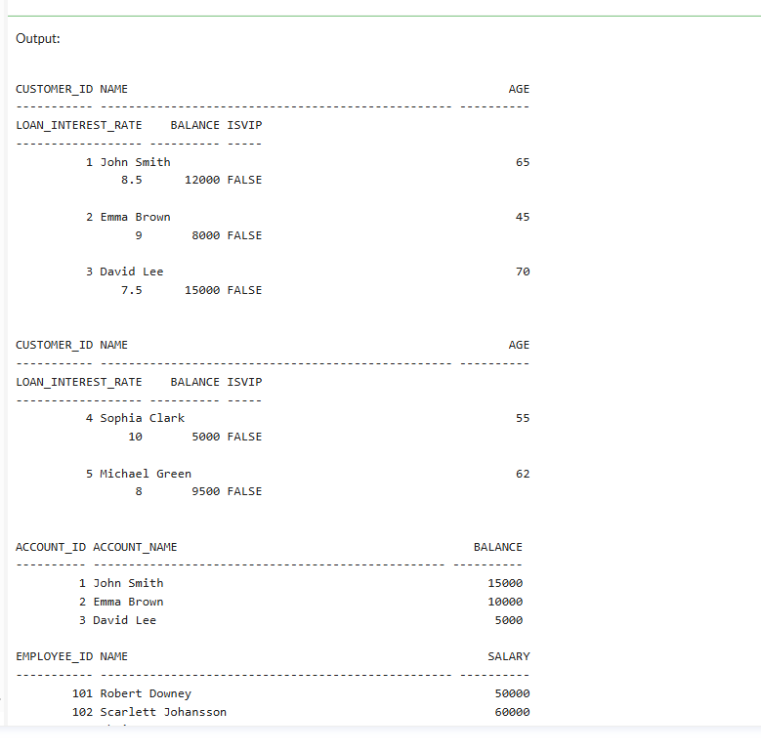

**Exercise 3: Stored Procedures**

**Output:**

